Complete Change Plan for Terra Nova
Melissa Alloggio, Jaime Lane, Robert Kinnick, Horace Winston
HRM/310
July 10, 2017
L. J. Elliott

Complete Change Plan for Terra Nova
Introduction
Action Steps
To effectively implement the change process for Terra Nova, the following action steps must be taken. In John Kotter's change model, there are eight action steps that need to be made to facilitate a successful change. The measures should be taken concurrently and continuously for the best outcome, and they should affect change in the firm. It is also vital during the modification process for the entire company to be an active part of the adjustments. The first step is creating a sense of urgency. This step is significant and should come before all other measures because it helps excite people to participate and be a part of the upcoming change activity. The next step is to assemble the group that will empower and lead the change effort and should be combined with employees from all areas of the Terra Nova staff. Another key point to remember is to ensure that the team you put together stays within the traditional hierarchy (Kotter International, 2017). This group along with the senior staff members and the human resources department will be considered the key members to the adoption continuum. These key members should all be aware of the importance they hold in effectively communicating the change. They should also be interested and invested in the modification. The human resources department along with the group chosen to empower and lead the change should be knowledgeable of the upcoming process and should be onboard with the need for change for them to entice and excite the rest of the Terra Nova staff. The formation of a strategic vision and initiatives is the next step. This will steer the change effort. Next stage is to enlist a volunteer army which will help move the employees along in the right direction of adoption. The next step in the Kotter's change model is enabling action by removing barriers to accomplishing change. It is necessary to alter parts of the organization that may pose a threat to the change (Kotter International, 2017). Generate short-term wins in the following stage. In this step, it is important to produce wins, track how the change is affecting the company, evaluate and adjust as necessary, and celebrate the little as well as the big accomplishments (Kotter International, 2017). The AIDA chart is a great tool to use for this step to track the small wins.
Key Player Name | Aware? | Interested? | Desires Action? | Adopter?
Terry O’Reilly |  |  |  | X
Partners | X
Senior Executives |  | X
Office Manager Teams |  |  | X

This move is also great to track the commitment to the adoption of the change to see if they are letting it happen or contributing to the change. In this step, a responsibility chart often helps since it holds people accountable to their task. The responsibility chart also helps all employees keep track of where they stand in the change process.
Actions or Decisions | Terry O’Reilly (President) | Senior Stakeholder | Human Resources | Entire Staff
Step 1 | RSI | A | SI | S
Step 2 | RASI | ASI | SI | SI
Step 3 | R | ASI | SI | SI
Step 4 | RASI | ASI | SI | SI
Step 5 | RAI | RAI | RSI | RI
Step 6 | RAI | RAI | RSI | RI
Step 7 | R | R | R | R
Step 8 | R | R | R | R
Coding:
R = Responsibility (not necessarily authority)
A = Approval (right to veto)
S = Support (put resources toward)
I = Inform (to be consulted before action)
The next step is to ensure and sustain acceleration; there must be increasing credibility to change and align the new idea. The final step is to introduce the change.
Contingency Planning
Measurement of Change (Melissa)
Terra Nova will be measuring the change about six months after the changes were first implemented. The change in the organization is so complex that in order to see all of goals met, and differences that they have made in the company measurements will be taken. Organizational culture at Terra Nova at about six months to a year after the first change is one of the easiest changes to measure, you can see if there is success just by looking over employee morale. Employee morale is something that someone or most leaders, managers, CEO’s can see just by walking around the organization. However, there will be surveys delivered to each employee with questions relating to how satisfied the employees are with some of the new changes, new duties, leadership etc. “Feedback through completed surveys can provide a lot of information to the organization; because acceptance of change will show in the employee’s improved job performance, less work stress, and more organizational commitment” (Cawsey, Deszca & Ingols, 2016, P. 341). The ways to measure if the spending, the change to receivables and the frozen stock purchases has proven effective, would be to review financial statements at the end of every quarter and notice the differences. The new hierarchy implemented into the organization and controls would be what is a little bit harder to measure. When the new hierarchy is formed, there are a lot of shifts in positions, job duties, controls etc. The best way to see if this structure has given the organization more success would be to create a balanced score card. The balanced score card is “an integrated set of measures built around the mission, vision, and strategy. Measures address the financial perspective, customer perspective, internal business process perspective, and learning and growth perspective” (Cawsey, Deszca, & Ingols, 2016, P.356).The balanced score card is able to keep all of the measures organized and together so you can see the organization in all its complexities.

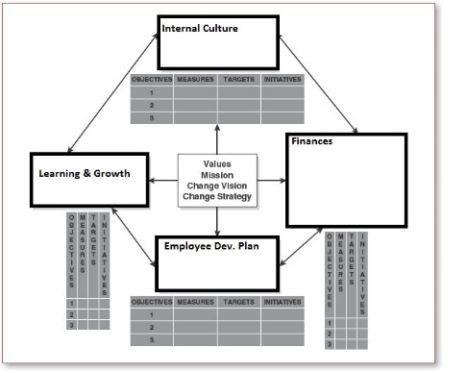s.

Transition Strategy
Conclusion

Reference
Kotter International. (2017). 8-STEP PROCESS. Retrieved from https://www.kotterinternational.com/8-steps-process-for-leading-change/
Cawsey, T., Deszca, G., & Ingols, C. (2016). Organizational Change: An action-oriented toolkit (3rd ed.). Thousand Oaks, CA: Sage Publications.

